
Wipro PARI Group
Standard Functions

Overview
Functionality description and usage information of standard function block developed by Wipro PARI.
Item Name: | Folder Scan Process Doc
Classification: | Tools
Item Code: | DOC000104963
Reviewed By: | Swapnil A. | Reference Project Code | Nil

Version History
Version No. | Date | Revision By | Revision Note(s)
1.0 | 13-Feb-2024 | Harshal Gharmode | Initial release
1.1 | 10-Oct-2024 | Harshal Gharmode | Update folders function added
Created by | Harshal Gharmode
Approved by | Atul Patwardhan

Folder Scan Process Document
This tool available on Ex-Dm. (refer below path)
https://exdm.wipropari.com:8084/ERPStandardItems.aspx?ItemCode=DOC000104963
Open FolderScan.exe – Shortcut (Refer below snap for icon)

Click on Run
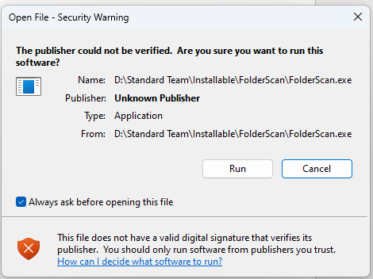

There are two functions available
- Folder scan
This function is use for the find the backup from OneDrive above defined size.

- Copy the path of OneDrive folder & paste under Directory path
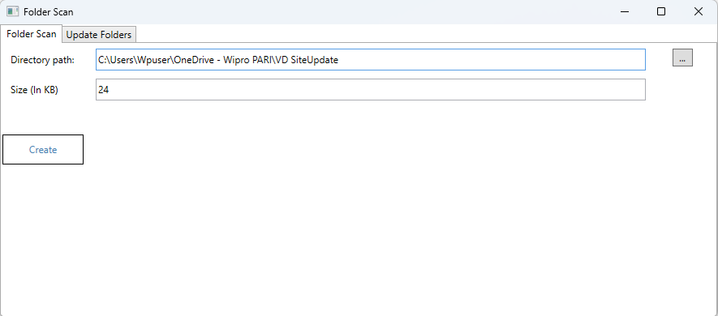
- Copy the path of OneDrive folder & paste under Directory path
- Define the size of folder, folder scan finds the backup above defined folder size.
- Click on create to find backup
- CSC created successfully -Click on OK
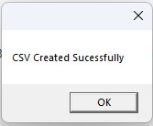
- Generates two .CSV excel file automatically saves under Temp folder of PC.
- In Files named csv finds unwated backup placed in OneDrive folders.
- In ProjectFolderList named csv finds backup folder path, and folder creation datetime.

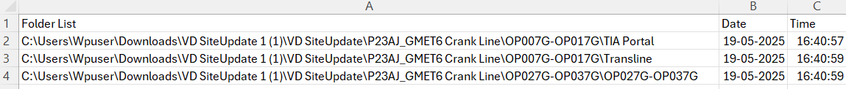
ProjectFolderList.csv

2. Update folders
This function is use for the clear the backup under ProjectData.zip folder when backup check-out as Supplier Check-out
- Copy the path of folder which is to be clear.
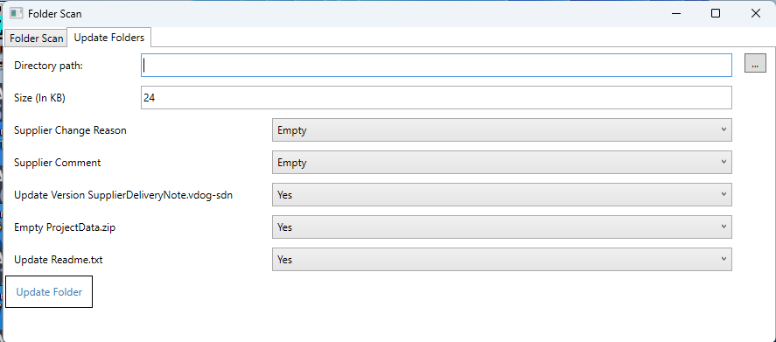
- Define the size of folder, clear the backup above defined folder size.
- Set all settings as per below snap
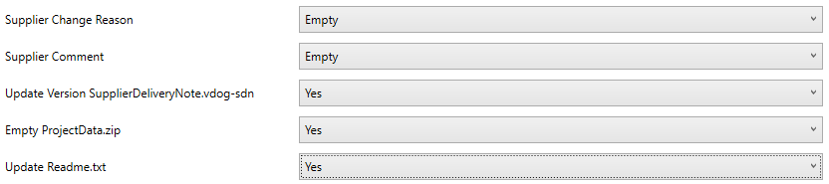
- Click on Update Folder to clear backup
- Folder Updated Successfully -Click on OK


